

Analysis and interpretation of relationship between Crime and GDP using VAR (Vector Auto-Regression) Model.

**Name:** Anumoy Modak

**Roll No**: ME22002

**School:** School of Economics, XIM University

**Paper:** Time Series Econometrics.

**Guide: Dr. Sandip Sarkar**

# **Introduction:**

Vector Autoregressive (VAR) models are widely used in time series research to examine the dynamic relationships that exist between variables that interact with one another. In addition, they are also important forecasting tools that are used by most macroeconomic or policy-making institutions.

## **Hypothesis:**

If we consider a population or a part of it which goes apart of socially accepted moral process and human behaviour defines **‘Crime’**. So, crime is border line which creates a literary interpretation for those who goes opposites of Idealized social process and Norms. Thereby, **it will affect the GDP** and the **over-all welfare of the society** and the economy as a whole. This is the empirical analysis to interpret the relationship between Crime and GDP using VAR model.

## **Analysis of the variable used: Summery Statistics (Mean and Median).**

The variables used : Violent Crimes, Murder, Robbery, Theft and US GDP percapita. Where, US GDP percapita taken as the dependent variable and rest are independent variable. It is the US dataset having 11 crime entities out of which 5 variables used for finding out the relationship with GDP percapita of US. The Excludetion process of remaining 6 variables done through stationarity test (Augmented Dicky Fuller Test and DFGLS test) which will be discussed later in the methodology section.

**Tabular Presentation (1):**

|  |  |  |
| --- | --- | --- |
| Variables | Mean | Median |
| Violent Crime | 468.438 | 468.4 |
| Murder | 6.37 | 6.55 |
| Robbery | 162.46 | 149.75 |
| Theft | 402.13 | 431.85 |
| US_GDP_percapita | 26168.76 | 23351.36 |

From the above the tabular presentation, we can see the range of difference between the two measures i.e., mean and median the variables used is not too big except robbery. There is low skewness in the variables used

# **Illustration of Variables used in the project:**

* **Violent Crimes**: In the context of economics, violent crimes are criminal activities that involve the use of force or threat of force to harm or intimidate individuals. It causes both direct and indirect impact on the society and the welfare of the economy as a whole. Such as: loss of productivity, impact on human capital, medical cost increases for victims, causing fears leads lower tourism and transportation business.
* **Murder:** In economic terms, murder refers to the unlawful and intentional killing of another person, and its economic implications are multifaceted. While the primary focus of murder is on its legal and moral dimensions, it also has economic consequences that affect individuals, communities, and society as a whole. especially in the loss of human capital.
* **Robbery:** In economic terms, robbery refers to a criminal act where an individual or a group forcibly takes property or valuables from another person, typically through the use of threats, intimidation, or violence. The economic implications of robbery are multifaceted and can affect individuals, businesses, and society as a whole.
* **Theft**: In economic terms, theft refers to the unlawful taking of someone else's property with the intent to permanently deprive the owner of that property.
* **US_GDP_percapita**:

# Methodology:

## **Checking for stationarity: Dicky Fuller & DFGLS.**

As mentioned above, the US dataset having 11 crime entities out of which 5 variables used for finding out the relationship with GDP percapita of US. The Excludetion process of remaining 6 variables done through stationarity test (Augmented Dicky Fuller Test and DFGLS test).

**Firstly,** we have taken all the 11 variables such as : Total Crime, Violent, Property, Murder, Robbery, Aggravated assault, Burglary, Larceny Theft, Theft, US_GDP_total and US_GDP_percapita and testing for stationarity using Augmented Dicky Fuller test in which the output is insignificant i.e., non-stationary at all levels (1%, 5%, 10%) for all variables. The main reason is the lack of having any pattern as there is an unseen time effect in the variables.

**Secondly,** applying First difference method i.e., converting from values to change values of respective variables for removing the unseen time affect in the variables. Then running the stationary test using Augmented dicky Fuller test. Where, we get: **violent, murder, robbery, Theft and US_GDP_percapita satisfies the stationarity condition or we can say these variables are stationary**. Similarly, for **DFGLS test** we have used the first difference of all the variables which are used previously and got the same result as above (**violent, murder, robbery, Theft and US_GDP_percapita satisfies the stationarity condition or we can say these variables are stationary**.)

**Tabular Presentation (2):**

Table 2: Significance at : 1% = ***, 5% = **, 10% = *]

|  |  |  |  |  |
| --- | --- | --- | --- | --- |
| Serial No. | Variables | Dickey-Fuller Statistic (With Trend) | Dickey-Fuller Statistic (Without Trend) | GLS-ADF calculated Statistic (significant lag) |
| 1 | Violent | -3.909 (**) | -3.213 (**) | -3.621 (**) (at lag 1) |
| 2 | Murder | -4.195 (*) | -3.885 (*) | -4.399 (*) (“) |
| 3 | Robbery | -4.338 (*) | -3.44 (**) | -4.416 (*) (at lag 2) |
| 4 | Theft | -3.912 (**) | -3.242 (**) | -3.492 (**) (at lag 1) |
| 5 | US_GDP_percapita | -4.975 (*) | -3.109 (**) | -4.539 (*) (at lag 1) |

## **Plotting graph for used variables : before and after using first difference.**

1. **Before using first difference:**

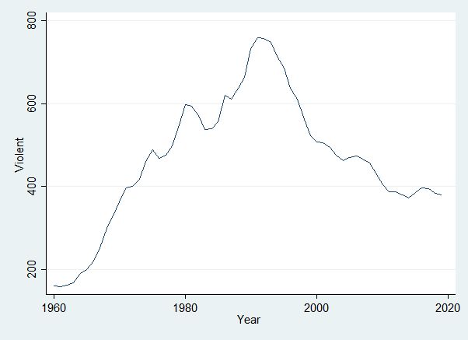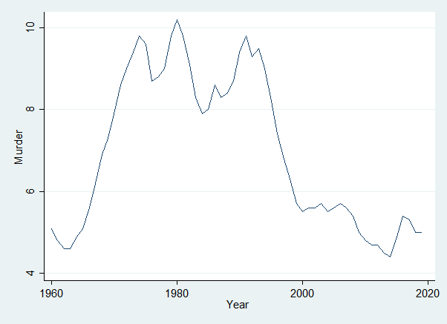

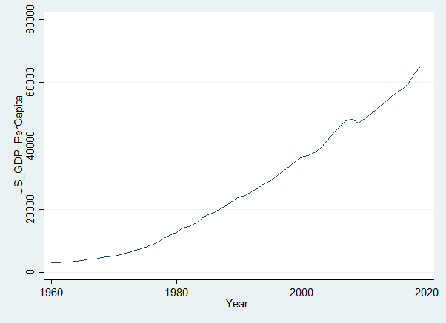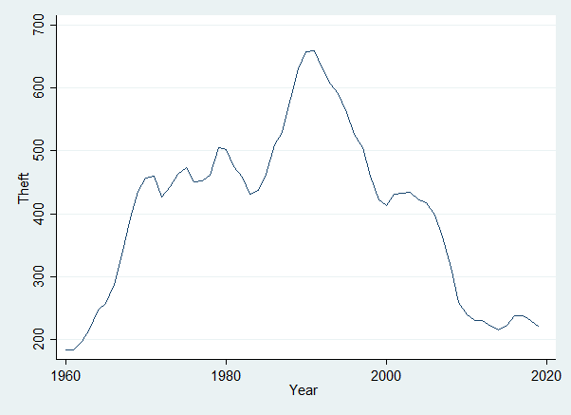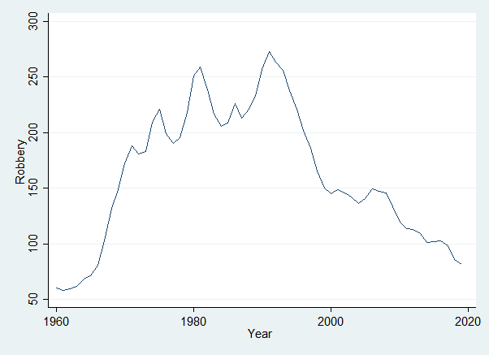

1. **After using the First difference:**

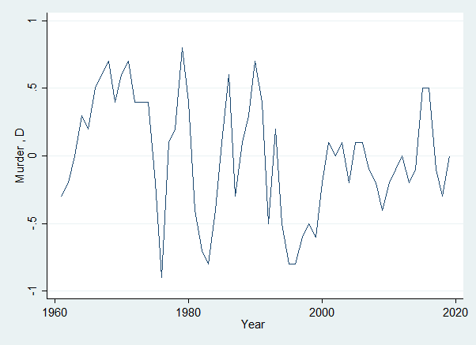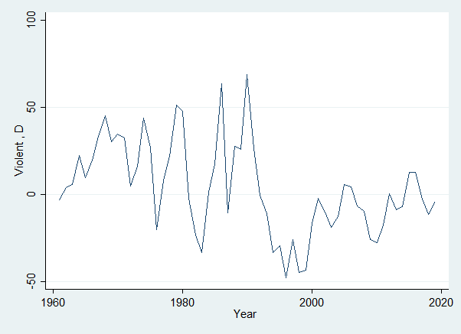

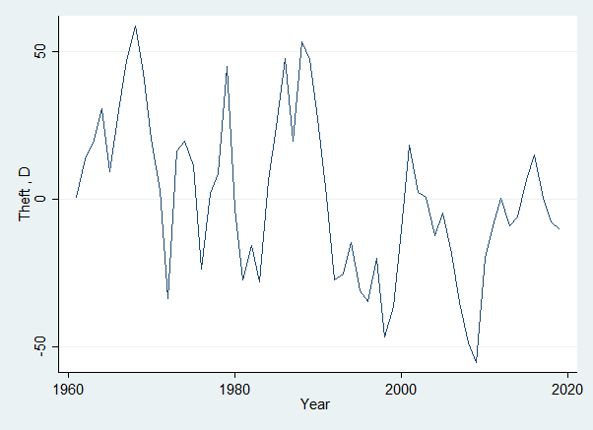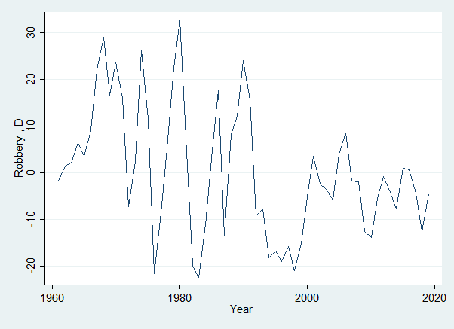

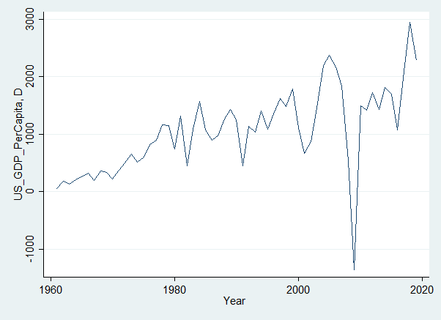

## **Detrending the variable and plotting the graph of Detrended Variables:**

Detrending is the method of converting the variable from time variant to time invariant as with some variable there is an invisible time affect. Against every taking time as an independent variable have obtained residuals which serve as detrended values.

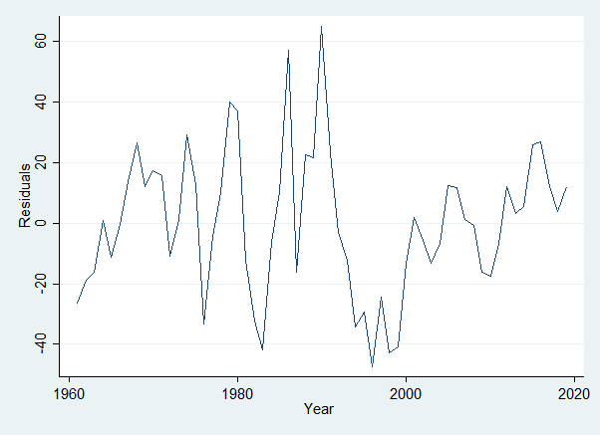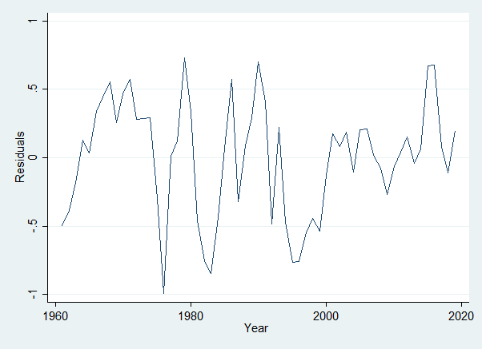**Plotted graphs of Detrended Variables:**

detrended_Drobbery

Detrended_Dmurder

detrended_Dviolent

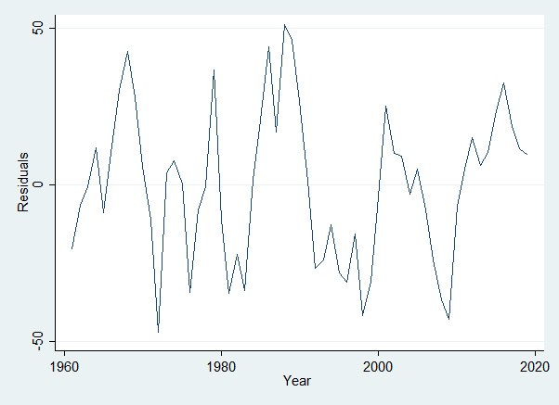

detrended_Dtheft

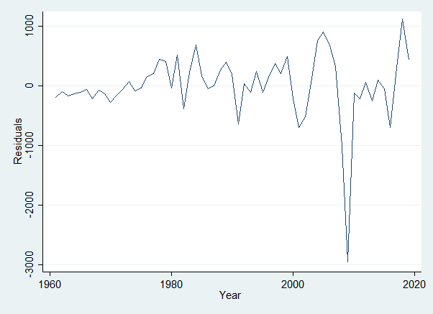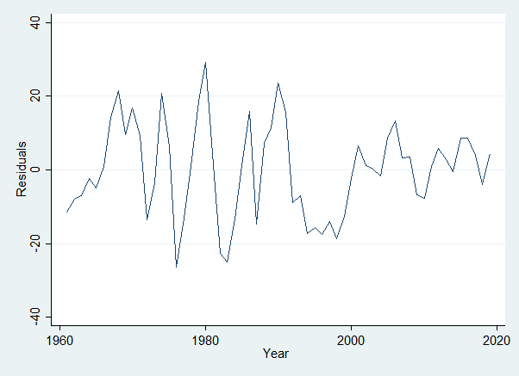

Graph 1detrended_Dus_gdp_percapita

## **There is no ARCH effect so we will use AR Specification in VAR model:**

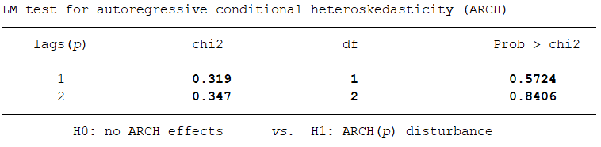from the above table we can see, the p value is greater than all the significance level (1%,5%,10%) i.e., at lag 1 – 57% & lag 2 – 84% . Here, null hypothesis (H0) is within the accepted region where we can say null hypothesis cannot be rejected rather accepted. So, we can say There is no ARCH effects within the variable used.

So, thereby using AR specifications using VAR Model.

# **Analysis using VAR Model**:

Null hypothesis taken as – * **H0 : there is no relationship between the dependent variables taken (Violent, Murder, Robbery , theft) and independent variable ( us_gdp_percapita).* H1 : there is a relationship between the dependent variables taken (Violent, Murder, Robbery , theft) and independent variable ( us_gdp_percapita).** if p value of chi2 > 10% = **H0  is accepted ( no relations ),** p value of Chi2 < 10% = **H0  is rejected ( There is a relations ).**

1. Analysis 1:

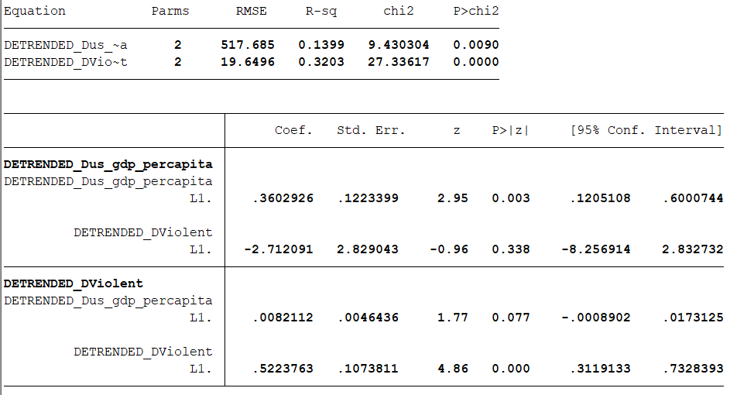

From the table, the overall specification of the relationship between Violent crime and us_gdp_percapita showing here significance at 1% with a value 0.0090 ( 0.9%). But it is necessary to check the specification alternatively.

1. Per unit change in the difference of Violent at lag 1 causes an insignificant ( at all critical levels : 1% , 5%, 10% ) change of value -2.712 in the difference of us_gdp_percapita year wise.
2. Per unit change in the difference of us_gdp_percapita at lag 1 causes an significant ( at critical levels : 10% ) change of value 0.008 in the difference of violent crimes year wise.

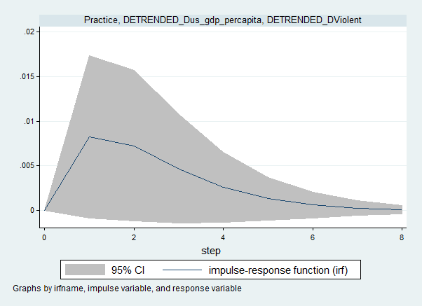

1. Analysis 2:

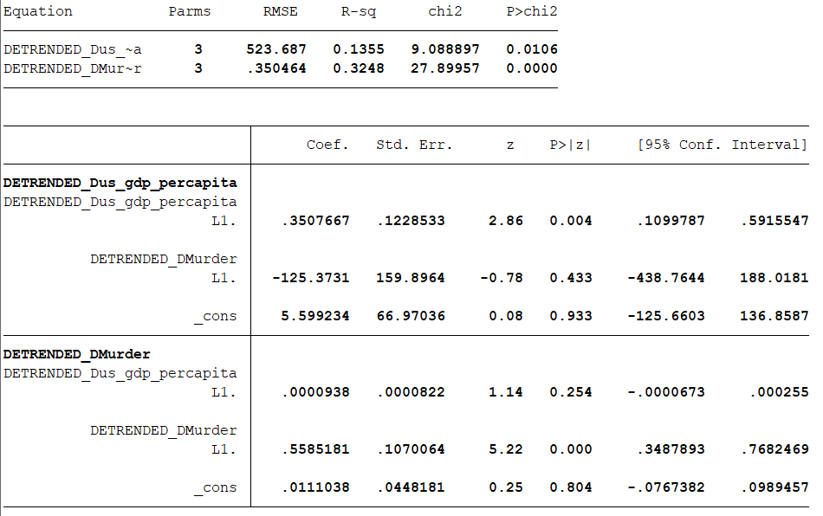

From the table, the overall specification of the relationship between Murder and us_gdp_percapita showing here significance at 5% with a value 0.0106 ( 1.06%). But it is necessary to check the specification alternatively.

1. Per unit change in the difference of Murder at lag 1 causes an insignificant ( at all critical levels : 1% , 5%, 10% ) change of value -125.373 in the difference of us_gdp_percapita year wise.
2. Per unit change in the difference of us_gdp_percapita at lag 1 causes an insignificant ( at all critical levels : 1% , 5%, 10% ) change of value .0000938 in the difference of murder year wise.

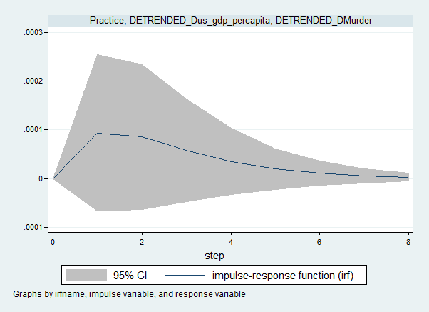

1. Analysis 3:

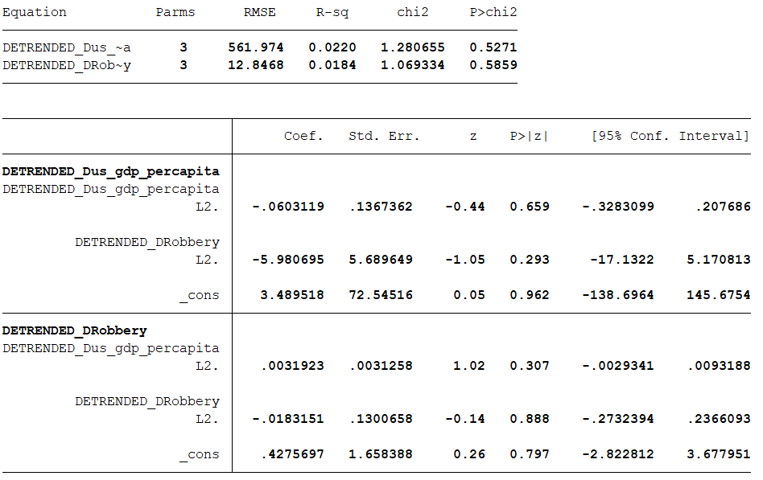

From the table, the overall specification of the relationship between Robbery and us_gdp_percapita showing here insignificant at all critical values with a value 0.5271 ( 52.71%).

1. Per unit change in the difference of Robbery at lag 2 causes an insignificant ( at all critical levels : 1% , 5%, 10% ) change of value -5.980 in the difference of us_gdp_percapita year wise.
2. Per unit change in the difference of us_gdp_percapita at lag 1 causes an insignificant ( at all critical levels : 1% , 5%, 10% ) change of value 0.0031 in the difference of robbery year wise.

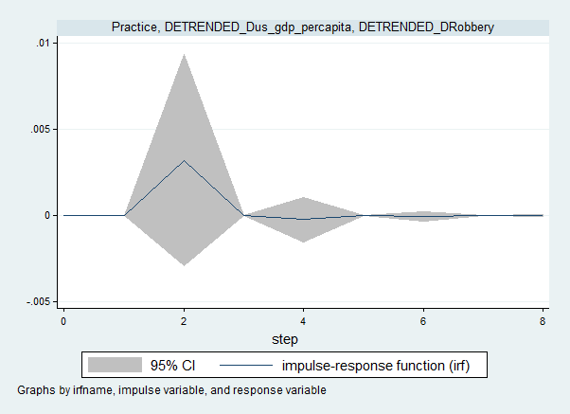

1. Analysis 4:

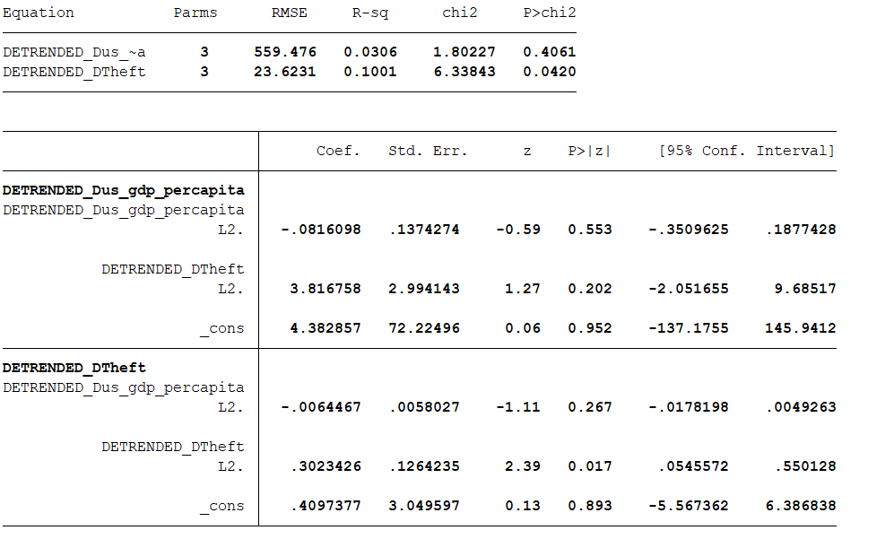

From the table, the overall specification of the relationship between Theft and us_gdp_percapita showing here insignificant at all critical values with a value 0.4061 ( 40.61%).

1. Per unit change in the difference of Theft at lag 2 causes an insignificant ( at all critical levels : 1% , 5%, 10% ) change of value 3.816 in the difference of us_gdp_percapita year wise.
2. Per unit change in the difference of us_gdp_percapita at lag 1 causes an insignificant ( at all critical levels : 1% , 5%, 10% ) change of value -0.0064 in the difference of theft year wise.

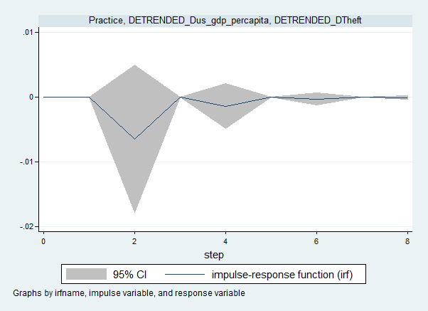

# **Conclusion:**

Violent crimes has a relationship between GDP percapita i.e., GDP is affecting on Violent crime but robbery and murder which are the element of violent crime by itself are insignificant. Thus the relationship of violent crimes & GDP is caused by other elements of violent crimes itself. Such as : Non-intentional homicides, arson, Kidnapping, Negligence, etc.

# **Reference:**

1. <https://www.disastercenter.com/crime/uscrime.htm>